EXPERIMENT 12
Port Scanning Tools
AIM : To perform port scanning in Kali Linux using Nmap and identify open, closed, and filtered ports on a target system.
DESCRIPTIONS
1.nmap –version
This command displays the installed Nmap version in Kali Linux.
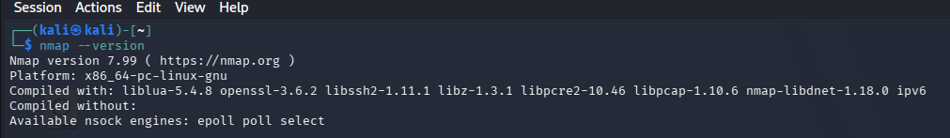
2. nmap 127.0.0.1
This command scans common ports on the local computer and shows their status.
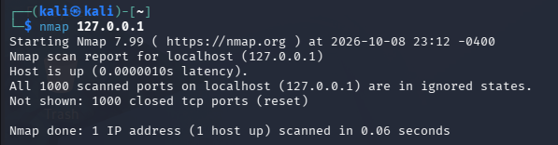
3. nmap -p 22,80 127.0.0.1
Scans only ports 22 and 80 on the local computer.
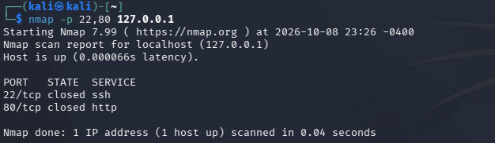

4.nmap -p- 127.0.0.1
Scans all TCP ports from 1 to 65535.
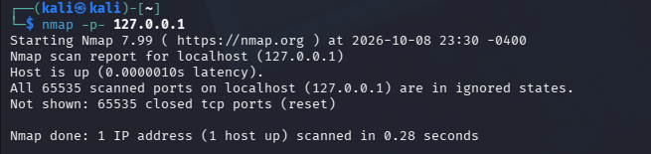
RESULT : Port scanning was demonstrated using Nmap in Kali Linux. The scan reports the target's reachable ports and their states.

